Planning Inspectorate Ref: APP/E5900/W/20/3250665

LPA Reference: PA/19/00804

TOWN AND COUNTRY PLANNING ACT 1990
(AS AMENDED)

Appeal

DE PAUL HOUSE (PANDA HOUSE), 628-634 COMMERCIAL ROAD, LONDON, E14 7HS

VIABILITY AND AFFORDABLE HOUSING

SUMMARY, UPDATE & REBUTTAL

By:-

James R Brown BSc (Hons) MRICS
Registered Valuer.
(James R Brown & Company Ltd – “JRBC” - regulated by the RICS).

On behalf of the Appellant
(Rooms and Studios Management Ltd)

23rd September 2020
CONTENTS

1.0 Professional Background
2.0 Viability
3.0 Background
4.0 Comments/Rebuttal - BNP Paribas Report
5.0 Comparison of Opinions & Key Issues.
6.0 Conclusion
7.0 Statement of Truth & Declaration

Appendices:-

A | Rapleys Viability Report
B | James Brown – Review of Comments
C | Create Schedule dated 14/10/2019
D | RLF Costing – Chatfield Road

1.0 Professional Background:-
1.1 My name is James R Brown BSc (Hons) MRICS and I am an expert in development viability and affordable housing.
1.2 I qualified as a Chartered Surveyor in 1992.
1.3 I have specialised in development viability and affordable housing since 2001 and focussed on affordable housing valuation before this.
1.4 Over the last 18 years, I have worked for; Savills plc, Hamptons International and Strutt & Parker LLP. I set up and headed viability & affordable housing departments at each of these firms.
1.5 I left Strutt & Parker in 2015 to establish James R Brown & Company Ltd which specialises in development viability and affordable housing.
1.6 Over the last 10 years, I have; spoken at numerous seminars on development viability and affordable housing, acted as Expert Witness at several planning appeals (with APP/C5690/W/18/3205926 being the most recent) and I am acknowledged as a participant in the production of “Financial Viability in Planning – Guidance Note 94/2012 – 1st Edition – Royal Institution of Chartered Surveyors (“RICS”)”. I have also contributed to the RICS’s latest draft guidance on this subject (i.e. ‘Assessing Financial Viability in Planning under the National Planning Policy Framework for England’) and I made formal representations on behalf of several clients in connection with the draft London Plan EIP in 2019.
1.7 I have submitted development viability and affordable housing representations on over 300 development proposals across England over the last 10 years for applicants or local authorities, the majority of which have been in Greater London.

2.0 Viability:-
2.1 A development is viable if it drives a residual land value (allowing for a reasonable level of profit) which is at least equal to a reasonable Benchmark Land Value (“BLV”).
2.2 The viability test can be summarised as:-
Built Value of proposed private residential and other uses
Built Value of affordable housing
Build Costs, finance costs, other section 106 costs, sales fees, developers’ profit etc
=
Residual Land Value (“RLV”)
RLV is then compared to a Benchmark Land Value (‘BLV’). If RLV is lower and/or not sufficiently higher than the BLV – project is not technically viable
-
+

3.0 Background:-
3.1 Rapleys produced a viability report (see Appendix A) dated 3/12/2019 in connection with the original planning application for what is now the Appeal Scheme. The Rapleys report concluded that the Appeal Scheme could not viably sustain any affordable housing provision.
3.2 In the report to committee dated 12/3/2020, the only significant viability comments/opinions made by the London Borough of Tower Hamlets (‘LBTH’), and which were reported to have been provided by LBTH’s Viability Team, were in their Sections 5.41, 5.42 and 7.27. These comments/opinions were unsubstantiated with any specific evidence.
3.3 The application was refused on 18/3/2020 whereupon the first reason for refusal was:-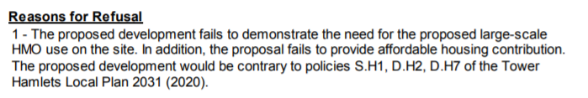
3.4 LBTH did not produce any form of viability report prior to refusal and so the applicant effectively had no opportunity to reasonably discuss LBTH’s concerns professionally.
3.5 I was asked to comment on the LBTH Committee report in May 2020 which I did via a written ‘Review of Comments’ dated 16/6/2020 (see Appendix B).
3.6 In responding to the appeal, LBTH produced their Statement of Case (undated but which was copied to me on 31/7/2020) which ‘introduced’ a viability/affordable housing report produced by BNP Paribas (‘BNPP’) dated 27/7/2020.

3.7 Bearing in mind the content of the BNPP report dated 27/7/2020, and whilst I am not a planning consultant, the original reason for refusal highlighted above appears to have been invalid because the BNPP report effectively indicates that 84 of the 109 proposed bedrooms within the Appeal Scheme are ‘naturally’ affordable (i.e. the maximum potential rents to be charged without any S.106 affordable housing restriction already meet certain policy based affordability criteria).
3.8 In their recent Statement of Case, LBTH have expanded upon their affordable housing related reason for refusal as follows:-
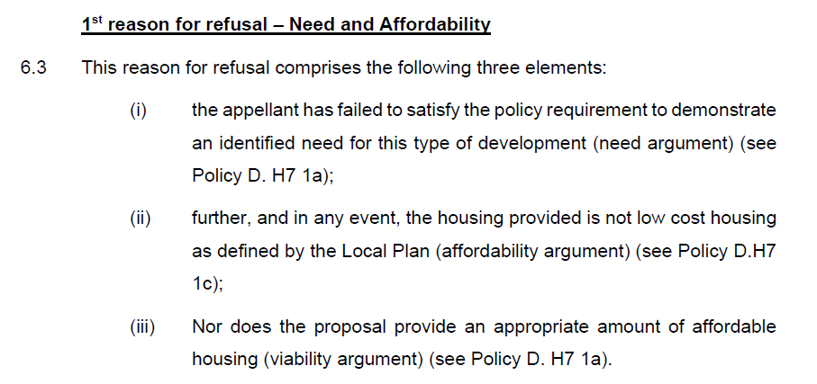

3.9 At Sections 4.5 and 4.6 of the BNPP report dated 27/7/2020, they say:-
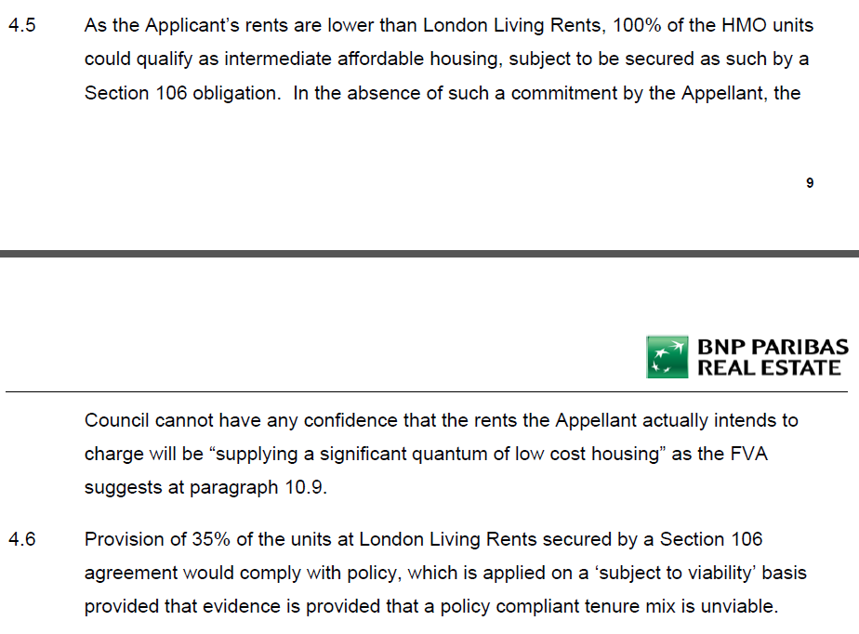
3.10 As such, it appears that there is a greater affordable housing provision within the Appeal Scheme than policy requires.
3.11 LBTH’s updated First Reason for Refusal (iii) does not seem valid in light of the BNPP report. I am not a planning consultant but their First Reason for Refusal (ii) also seems questionable.
3.12 I focus herein on what I think the viability of the Appeal Scheme is and whether any formal affordable housing restrictions/conditions (i.e. as would be embodied in a Section 106 Agreement) would detrimentally affect its viability and/or deliverability.
3.13 At Section 6.34 of LBTH’s Statement of Case, they say the following are now the main items of dispute regarding viability:-
- Existing hostel rental value.
- Build costs.
- Floor space calculations.
- Benchmark Land Value.

3.14 However, the BNPP report indicates that we are agreed on the BLV at £5.89m and I clarify herein why there is no floor space issue. This leaves:-
- Existing hostel rental value, and;
- Build costs.
4.0 Comments/Rebuttal – BNP Paribas Report
4.1 In Appendix 1 to the London Borough of Tower Hamlets (‘LBTH’) Statement of Case is a viability report prepared by BNP Paribas (‘BNPP’) dated 27/7/2020.
4.2 My main sequential rebuttal comments on that are set out below:-
4.3 At BNPP’s S.3.6 and S3.7, they suggest there are errors surrounding total room areas, ancillary areas and the total GIA of the proposed scheme between the area schedule produced by the architects (Create) and cost consultants (3-Sphere), both of which were included within the appendices to the Rapleys viability report dated 3/12/2019.
Whilst there was an error in Create’s schedule in terms of the total NIA for the ancillary area, this had no bearing on the viability assessment carried out by Rapleys because their proposed scheme GDV was driven by the number and average size of the bedrooms. Furthermore, the error had no bearing on the cost assessment carried out by 3-Sphere because the Create schedule within the Rapleys report was out of date and 3-Sphere had based their schedule on what became and remains the correct schedule for the Appeal Scheme.

BNPP question why Create’s area schedule refers to a “gross floor area” of 3,832 sq.m. whereas the 3-Sphere schedule reports a total scheme GIA of 4,551.40 sq.m. The answer to this is that, as can be seen from the Create schedule, their total area of what should have been approximately 3,832 sq.m. was not a ‘gross floor area’. It was clearly labelled as a NIA which is why it is less than 4,551.40. Furthermore, BNPP’s cost consultant (‘RLF’) have measured the total scheme GIA to be 4,556 sq.m. and so the costs consultants are effectively agreed.
The accommodation schedule in BNPP’s Table 3.4.1 does not reflect the correct schedule for the Appeal Scheme. I understand the correct Appeal Scheme and Appeal Scheme areas (based upon the Appeal Scheme schedule produced by Create dated 14/10/2019 – see Appendix C) and the total GIA measurements carried out by 3-Sphere (as effectively corroborated by RLF) are:-
Hostel:- | Nos | Average NIA per Bedroom (sq.m.) | NIA (sq.m.) | Occupants
Single Rooms | 9 | 15.44 | 139.00 | 9
Twin Rooms (non exclusive) | 12 | 19.13 | 229.50 | 24
Accessible Rooms (non exclusive) | 4 | 27.25 | 109.00 | 8
Totals | 25 | 19.10 | 477.50 | 41
HMO:- | Nos | Average NIA per Bedroom (sq.m.) | NIA (sq.m.) | Occupants
Single Rooms | 24 | 15.35 | 368.50 | 24
Double Bedded Rooms | 52 | 19.42 | 1,010.00 | 104
Accessible Rooms | 8 | 25.56 | 204.50 | 16
Totals | 84 | 18.85 | 1,583.00 | 144
Total Scheme GIA = | 4,551.40 sq.m.

BNPP question what frequents the area being the difference between 2,060.50 sq.m. (bedrooms area) and 4,551.40 sq.m. (total scheme GIA). This comprises ‘gross’ ancillary areas and communal parts.
In conclusion, despite an insignificant error on an earlier version of the Create area schedule, it is BNPP who are in error and have used the wrong areas for the Appeal Scheme. There is no issue in terms of the relationship between the 2,060.50 sq.m. (bedrooms area) and the total scheme GIA of 4,551.40 sq.m.
I assume this deals with the floor-space issue referred to in LBTH’s Statement of Case as referred to in Section 3.13 above.
4.4 In BNPP’s S.6.6 to 6.9, they say I have used the same income assumptions as Rapleys in my ‘Review of Comments’ dated 16/6/2020 (see Appendix B) and that Rapleys and I are in error with regard to the potential income we have assessed for the Appeal Scheme based upon their comparison of the existing hostel and the proposed hostel element of the Appeal Scheme.
However, neither Rapleys or I are in error in this regard BNPP’s comparison of the potential income from the existing hostel versus the proposed hostel element of the Appeal Scheme is inappropriate because they are conceptually different. The existing hostel comprises rooms containing multiple bunk-beds whereas the proposed hostel moves away from that and is designed to cater for fewer people per room. BNPP appear to be saying that the proposed new hostel rooms should generate the same gross income as the existing ones but this does not follow if there are far fewer occupants per room. I understand that the Appellant is not planning to revert to the existing hostel concept (i.e. by putting multi-bunk beds in the proposed new rooms).

The existing hostel comprises 52 rooms and can accommodate up to 263 people. The average room size is just under 28 sq.m. and so each person has apportioned space of 5.53 sq.m. As replicated in Section 7.6 of my Review of Comments, the accounting history for the existing schemes indicates an approximate gross rent over the last 2 years of around £1.46m p.a. If it was 100% full 365 days of the year, this would equates to £5,551 per person/bed p.a.
The proposed hostel element of the Appeal Scheme comprises 25 rooms and can accommodate up to 41. The average room size is 19.1 sq.m. and so each person has apportioned space of 11.65 sq.m. which is obviously bigger and better quality space (i.e. in spatial, shower access and privacy terms) than within the existing hostel. In their original viability report Rapleys accounted for a gross rent of £8,683 per person p.a. (i.e. 56.42% higher) for the proposed hostel element of the Appeal Scheme to reflect the bigger and better space per person. Although a better gross rent per room would be obtained by pursuing the existing hostel concept (i.e. multiple bunk-beds per room), the net rental position is worse (partly on account of higher resident turnover).

BNPP have assumed that the same gross rent per room could be obtained via the proposed hostel element of the Appeal Scheme as per the existing hostel but this is not reasonable because there will only be an average of 1.64 people paying rent/fees per room in the Appeal Scheme hostel compared to 5.06 people paying rent/fees per room in the existing hostel. As such, BNPP’s application of the same gross room income per annum for the Appeal Scheme hostel as per the existing hostel is flawed.
In BNPP’s Appendix 3, they identify a total gross annual rent for the proposed hostel of £784,176 p.a. (albeit they appear to have higher rents for single occupancy units than they do for double occupancy rooms – which does not make sense). Based upon £784,176, this equates to £16,003 per person/bed p.a. compared to the average of £5,553 p.a. per person/bed within the existing hostel. This is a 188% increase which is illogical and clearly excessive notwithstanding the Appeal Scheme hostel bedroom space per person is bigger and better.
I assume this deals with the hostel income issue referred to in LBTH’s Statement of Case as referred to in Section 3.13 above.
4.5 In BNPP’s S.6.9, they say it is counterintuitive that the same room rate would apply to hostel and HMO units, the latter intended for longer term occupation and the former for short stays. They refer to the Rapleys assumptions of:-
Single - £1,000 p.c.m.
Double - £1,083 p.c.m
Accessible - £1,100 p.cm.
BNPP say that the Rapley’s gross achievable annual income for the proposed single hostel rooms (i.e. £12,000 p.a) equates to £2.73 per room or per person per night. However, this is incorrect as it equates to £12,000/365 = £32.88 per night. BNPP also claim that the Rapleys room rate per night per double room (which is actually envisaged as being a twin room without exclusivity) equates to £2.96 per night. However, this is also incorrect as it equates to £17.80 per person per night (i.e. £12,996/365/2 = £17.80 per night). It would appear that BNPP have not multiplied the monthly rent by 12 before dividing it by 365. BNPP then compare their £2.73 and £2.96 to ‘asking’ rates within the existing hostel where room ‘sharer’ rates (i.e. sharing with what could be strangers) range from £14 - £24 per night with the highest rate being in a 4 person room.
In my opinion, the hostel room rates Rapleys assumed for single rooms are too low per person per night although the cap here is what single room rates are in budget hotels nearby (whereupon I consider it reasonable to assume a premium would be achievable in a hotel compared to a hostel based upon better brand awareness, concept awareness and perceived personal safety). Bearing this in mind, I note that the following (for example) was available on 17/9/202 (including breakfast):-
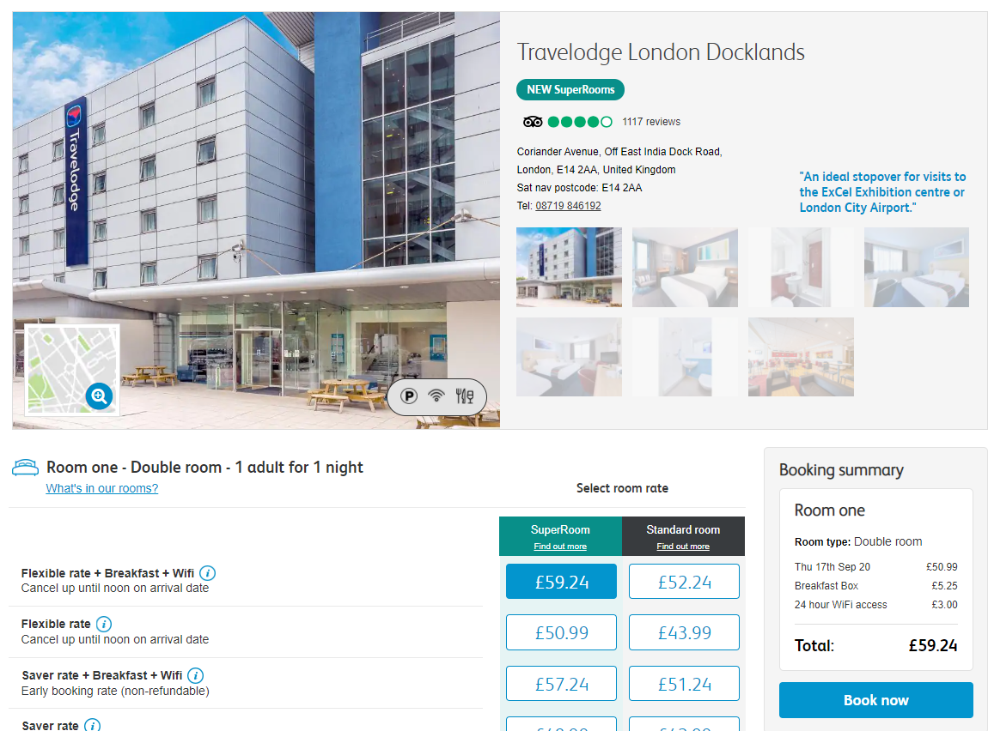

Although exclusive twin and double room ‘asking’ rates at the existing hostel have recently been £79.20 per night and £84.60 per night, I consider these rates to be overly-optimistic in light of the competition. A rate of £45 per night seems more appropriate and still optimistic bearing in mind the room at the Travelodge above is a double room.
With respect to twin rooms (non-exclusive), I consider that prospective sharers would prefer to share with a larger number of strangers than one. As such, I would not expect achievable rates in these rooms to more than £20 per night per person and the same would apply to non-exclusive accessible rooms accommodating 2 people per room.
As such I consider the achievable gross rents from the proposed Appeal Scheme hostel element to be:-
Singles @ £45 per night x 9 people x 365 days = £147,825 p.a.
Twins (non exclusive) @ £20 per night x 24 people x 365 days = £131,400 p.a.
Accessibles (non ex) @ £20 per night x 8 people x 365 days = £58,400 p.a.
----------------
£337,625 p.a.
My £337,625 is therefore lower than the Rapleys total gross income assumption p.a.
My conclusion in light of my comments in Sections 4.4 and 4.5 above is that, there is no justification for BNPP to have increased our achievable gross annual rent assumption for the Appeal Scheme hostel element from circa £340,000 p.a. to £784,176 p.a. and/or to add £4,607,153 to the Rapleys and/or my GDV. BNPP have over-stated their GDV by at least £4,607,153 which, if corrected, completely erodes the viability surplus BNPP claims to exist.
I assume this also deals with the hostel income issue referred to in LBTH’s Statement of Case as referred to in Section 3.13 above.
4.6 In BNPP’s S.6.12, they claim that Rapleys and/or I have not accounted for any food and beverage (’F&B’) income in valuing the Appeal Scheme. My valuation approach has been based upon investment transaction comparables where it is likely that some food and beverage income featured. Rapleys and Savills have not explicitly accounted for any F&B income in their net rent capitalisation approach.
BNPP refer to the gross F&B income that has been reported as being achieved for the existing hostel at £8,800 per month and have gone onto to assume a gross F&B income for the Appeal Scheme of £6,000 per month. However:-
- the existing hostel accommodates up to 263 people without access to their own or any significant communal kitchen facilities whereupon there is a large captive markets served by a central commercial kitchen/café.
- the Appeal Scheme accommodates 185 people whereupon there are communal kitchens for the residents to prepare their own food and beverages and where there is no proposed central commercial café.
There will be no scope to generate £6,000 p.c.m. within the Appeal Scheme and so it is not appropriate for BNPP to add £593,000 of extra GDV to reflect this.

4.7 In BNPP’s S.6.14, they refer to a build cost review prepared by RLF which has led them to assumed build costs for the Appeal Scheme that are £1,250,140 less than assumed by Rapleys (who used a build cost assessment provided by 3-Sphere).
The 3-Sphere build cost estimate (as at Q4 2019) equated to £305 per sq.ft. (£3,283 per sq.m.) including a contingency but excluding professional fees.
RLF (acting for BNPP) consider that the build cost should be £271 per sq.ft. (£2,913 per sq.m.).
The Appeal Scheme is effectively a co-living led scheme which I assume is relatively difficult to price in construction cost terms as there have been very few co-living schemes built.
I am aware (see Appendix D) that RLF also reviewed costs on a co-living led scheme at Chatfield Road (L.B. Wandsworth) where that scheme comprised:-
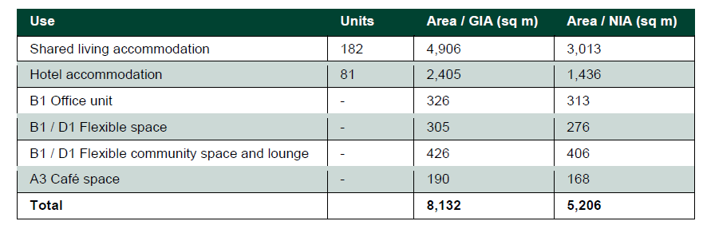
I would expect the Chatfield Road scheme to attract greater construction cost economies of scale compared to the Appeal Scheme whereas RLF considered a total build cost at Chatfield Street equivalent to £290.42 p.s.f. (3,126 p.s.m.) as at Q4 2019 (i.e. higher than for the Appeal Scheme). Also, although I am not a QS, some of the differences between RLF’s build costing for Chatfield Street compared to the Appeal Scheme relate to items that I would expect to be at least the same such as rates assumed for preliminaries and overheads and profit whereas, at Chatfield Street, RLF assumed preliminaries/overheads/profit at 17% versus 19% for the Appeal Scheme.
Generally, I would expect RLF to arrive at a higher build cost rate for the Appeal Scheme compared to their cost review for Chatfield Road (i.e. much closer to 3-Sphere’s costing).
For the purposes of my viability opinion here, I have therefore used the 3-Sphere costing of £14,505,100.
I assume this deals with the build cost issue referred to in LBTH’s Statement of Case as referred to in Section 3.13 above.
4.8 In BNPP’s S.6.22, they claim that purchaser’s costs should not be deducted from any valuation of the Appeal Scheme.
However, viability in planning is meant to reflect viability from a hypothetical developer’s perspective because planning consents run with the land.
Despite this, BNPP seek to claim that purchaser cost deductions from any investment valuation of the Appeal Scheme would not actually be borne by the specific applicant here if they held onto the proposed scheme as an operational entity/investment. Whilst irrelevant, this is true. However, what BNPP fail to point out is that if one does not account for a sale of the proposed scheme at or soon after practical completion in a residual appraisal and/or in reality, development finance costs p.a. (which would far outstrip net operational income p.a.) would continue to compound on rolled up development debt for many years until such time that ‘payback’ is achieved. This would lead to a substantially increased finance cost which would outstrip the investment sale purchase costs we have accounted for.
I consider this BNPP point to be ‘misleading’ and irrelevant.
4.10 In BNPP’s S.6.21, they agree with my assumed BLV of £5.89m. I assume this deals with the BLV issue referred to in LBTH’s Statement of Case as referred to in Section 3.13 above.

5.0 Comparison of Opinions and Key Issues:-

5.1 The respective viability opinions as at 21/9/2020 are therefore as follows:-

Appraisal Assumption | Rapleys/  Savills/  3-Sphere as at 3/12/2019 | London Borough Tower Hamlets Viability Team – circa February/March 2020 | BNPP/RLF – subsequent opinion as at 27/7/2020 | James Brown as at 21/9/2020 | Comment
Existing Hostel:-

BLV | £8,000,000 | Implied as being less than £8m | £5,890,000 | £5,890,000 | A BLV is agreed between BNPP and I.
Appeal Scheme:-

Gross Achievable Income from hostel element | Circa £340,000 | No comment | £784,176 | £337,625 | I think BNPP have substantially over-stated this figure because they are failing to account for the differences between the existing hostel rooms, the Appeal Scheme hostel rooms and the number of people that are proposed to live in each. BNPP also think Rapleys and I have made errors in this regard whereas it is BNPP who are in error.
Gross achievable income from HMO/Co-Living Element | £1,042,150 | No comment | £1,012,872 | £1,042,150 | Could be agreed.
Food & Beverage Capital Value | £0 | No comment | £593,000 | £0 | There is no scope to generate commercial food and beverage income in the Appeal Scheme.
GDV of Appeal Scheme | £22,732,467 | No comment | £28,998,212  * (see important comments in Section 5.2 below) | £23,171,506 (on account of using lower purchaser costs) | BNPP’s GDV is substantially over-stated because of their net rent assumption for the hostel element of the Appeal Scheme and their food and beverage assumption.
Build costs | £14,505,100 | No comment | £13,254,960 | £14,505,100 | BNPP/RLF cost assumption looks low compared to RLC cost review of another co-living led scheme at Chatfield Road.
All other appraisal inputs | See Comment column to right | n/a | See Comment column to right | See Comment column to right | Agreed
Residual Profit | £0 | No comment | £4.6m + circa £890,000  * (see important comments in Section 5.2 below) | £0
5.2 If one considers BNPP’s S.4.5, S.6.10 – S.6.14 and S.7.1 – S.7.5 and their appraisal in Appendix 5 of their report, BNPP’s findings effectively indicate that 84 of the 109 rooms proposed within the Appeal Scheme will be ‘naturally’ affordable.
BNPP’s concern (which is not necessarily a ‘viability’ concern) is that, unless some of the HMO rooms within the Appeal Scheme are restricted to being affordable they might not remain affordable. However, current market rates are such that this is not happening and is not likely to happen.
BNPP’s appraisal in their Appendix 5 indicates that, in their opinion, the Appeal Scheme currently drives a viability surplus of around £890,000 because it drives a residual land value of £6,777,758 compared to an agreed BLV of £5,890,000. However, their appraisal relies upon a substantially over-valued hostel element (based upon a gross rent which is circa double what Rapleys and I consider reasonable) and build costs which appear too low.

6.0 Conclusion:-
6.1 In conclusion:-
- BNPP have over-stated the achievable gross rent and GDV contribution of the hostel element of the Appeal Scheme.
- BNPP also appear to have under-stated build costs.
- BNPP’s appraisal (see Appendix 5 to their report dated 27/7/2020) suggests that a viability surplus of around £890,000 exists based upon their Scenario D but this relies upon an excessive GDV (i.e. by about £5.61m in connection with an over-valuation of the hostel element and an inappropriate valuation ascribed to potential F&B) and a build cost assumption which appears to be about £1.25m too low. Correcting these two items would confirm a significant viability shortfall.
- I stand-by my residual profit appraisal as present in Appendix 1 to my ‘Review of Comments’ dated 16/6/2020 (see Appendix B).
- The Appeal Scheme already provides more than the maximum policy based affordable housing provision ‘naturally’ and the imposition of any formal affordable housing restrictions/conditions would be prejudicial to fundability and deliverability.

7.0 Statement of Truth & Declaration:-
7.1 Statement of Truth:-
7.1.1 I confirm that I have made clear which facts and matters referred to in this Rebuttal are within my own knowledge and which are not. Those that are within my knowledge I confirm to be true. The opinions I have expressed represent my true and complete professional opinions on the matters to which they refer.
7.2 Declaration:-
7.2.1 I confirm that I have drawn attention to all material facts which are relevant and have affected my professional opinion.
7.2.2 I confirm that I understand and have complied with my duty as an expert witness which overrides any duty to those instructing or paying me, that I have given evidence impartially and objectively, and that I will continue to comply with that duty as required.
7.2.3 I confirm that I am not instructed under any conditional or other success-based fee arrangement.
7.2.4 I confirm that I have no conflicts of interest.
7.2.5 I confirm that my opinion complies with the requirements of the RICS – Royal Institution of Chartered Surveyors, as set down in the RICS practice statement ‘Surveyors Acting as Expert Witnesses’.

