Proof of Evidence  Land off Pump Lane, Rainham  APP/A2280/W/20/3259868 |  | Sweco UK Limited  4th Floor, Radcliffe House  Blenheim Court  Solihull, B91 2AA  +44 121 711 6600
JANUARY 2021
Revision: 2
Prepared For: Medway Council

Status / Revisions

Rev. |  | Reason for issue | Prepared |  | Reviewed |  | Approved
2 | 26/01/21 | POE | KJ | 25/01/21 | AP/DH | 26/01/21 | KJ | 26/01/21

© Sweco 2019. This document is a Sweco confidential document; it may not be reproduced, stored in a retrieval system or transmitted in any form or by any means, electronic, photocopying, recording or otherwise disclosed in whole or in part to any third party without our express prior written consent. It should be used by you and the permitted disclosees for the purpose for which it has been submitted and for no other.

Table of Contents
1 Qualifications and Experience 9
2. Medway Aimsun Model 12
3. Model Functioning 15
4. Medway Aimsun Model Context 18
5. MAM Reference Case 21
6. MAM Assessments for the Land Off Pump Lane Development 26
7. Conclusions of MAM Assessments for the Land Off Pump Lane Development 30
8. Responses to Appellants criticisms of the MAM modelling work 37
9. Summary 40

Table of Figures
Figure 1 MAM Network in Medway 12
Figure 2 MAM Subnetworks 27
Figure 3 Reference Case 2028 traffic conditions along the A2 at 8.30am 35
Figure 4 2028 LRR Scenario 6 traffic conditions along the A2 at 8.30am 36

Table of Tables
Table 1 Comparison between MAM and Isolated Junction modelling 16
Table 2 Local link, junction and routes calibrated and validated in the MAM model close to the development 20
Table 3 MAM Traffic Growth versus NTEM Traffic Growth for Medway 24
Table 4 Level of Service Thresholds for junction delay 30
Table 5 Level of Service Thresholds for Link Speeds 30

Appendices

Appendix A Transport Assessments Guidance Note……………………………………….42
Appendix B Sections of MAM Validation Report …………………………………………….50
Appendix C TAG M3.1 Section 3.3……………………………………………………………326
Appendix D Highways England MAM Approval e-mail………………………………………331
Appendix E Medway Local Plan STA Forecasting Report………………………………….335
Appendix F Committed Residential Developments in Medway …………………………….384
Appendix G Committed Non-Residential Developments in Medway……………………….394
Appendix H Completions of Committed residential developments in Medway (2016-17)..404
Appendix I Completions of Committed residential developments in Medway (2017-18)….408
Appendix J Completions of Committed non-residential developments in Medway (2016-17).411
Appendix K Completions of Committed non-residential developments in Medway (2017-18).418
Appendix L Presentation Medway (December 2019 results)…………………………………….425
Appendix M Lower Rainham Report (October 2020)…………………………………………….488
Appendix N Lower Rainham Report Addendum (2037 Results)………………………………..573
Appendix O Lower Rainham Report Addendum 2 (2028 Results)……………………………..611
Appendix P Pump Farm Lower Rainham (Appellant’s Letter 8/12/2020)……………………..649
Appendix Q Letter to Simon Tucker RE: SWECO and outstanding matters (14.12.2020)….664
Appendix R LRR Growth Factors AM and PM…………………………………………………669

GLOSSARY OF TECHNICAL TERMS

Aimsun: Advanced Interactive Microscopic Simulation for Urban and Non-Urban is a traffic modelling software that allows the simulation of large-scale road networks at microscopic and macroscopic levels.

Generalised Cost Assignment in Aimsun: Vehicles in the macroscopic model select their path (or route) between an origin-destination pair based on the projected cost of each alternative path they can follow. The generalised cost is calculated based on the volume delay functions for links and centroid connections (see definition below), turn penalty functions and junction delay functions.

Calibration and Validation: Model calibration refers to adjusting model parameters such as network detail to ensure the model reflects observed traffic conditions and is fit for purpose. Model validation refers to comparing modelled and observed data that is independent to the calibration process.

Flow difference bandwidth plot: A plot produced by traffic modelling software which compares the link flows between two scenarios. According to the absolute value of the difference, a corresponding width is shown in the plot for each link.

Volume over capacity: The volume-to-capacity ratio (V/C) measures the level of congestion on a roadway by dividing the volume of traffic by the coded capacity of the roadway.

Centroid: or zone centroid represents a point or node within a zone boundary where zonal trip demand originates and is destined. The centroids are linked to the network via a centroid connector (see below).

Centroid connector: A theoretical link connecting a zone centroid with a modelled road link. A centroid connection is used to load flow to and from the network. Centroids can be connected to more than one modelled road link.

Select link analysis: A type of analysis that provides data regarding the paths of vehicles passing through a specific (or selected) link or links.

Level of Service (LOS): is a qualitative measure used to relate the quality of motor vehicle traffic service. LOS Is used to analyse roads and junctions by categorising traffic flow and assigning quality levels of traffic based on performance measures like queue delay. The LOS measure was developed in the United States and documented in the Highway Capacity Manual of the Federal Highway Administration. However, the concept is commonly used around the world, including in the UK.

Trip Ends: the total number of trips origins and destinations to and from a zone within a trip matrix

Furnessing: a simple distribution process to derive the future year trip matrix from the base year matrix ensuring that the row and column totals match the future trip ends.

Trip rates: show the number of traffic/people movements in and out of a development (or an average of a number of developments within the same land use category), for a given trip rate parameter factor. For example, when trip rates are calculated by Gross Floor Area (GFA), they are shown per 100m2 of GFA

TEMPro: The DfT’s Trip End Model Presentation program, the software that allows users to view the National Trip End Model dataset to derive car traffic growth forecasts.

National Transport Model (NTM): DfT transport model of UK, used to produce road traffic forecasts typically used to provide traffic growth factors for light and heavy goods vehicles.

Qualifications and Experience

I Karl Jarvis, am a Technical Director in Transport Modelling and have an Honour Degree in Geography from the University of Wales, Swansea and a Masters in Transport Planning from the University of Wales, Cardiff. I am a member of the Chartered Institute for Highways and Transport (CIHT), and I have worked in the industry for seventeen years.

My career began at Arup where I was a member of the Transport Planning Team supporting with Transport Modelling projects. Since, leaving Arup I have continued working in private consultancy working on a range of transport modelling and transport planning projects representing both public and private sector clients.

I have undertaken work including but not limited to the development, calibration, validation of transport models including forecasting and option testing for scheme assessments, transport assessments, funding bids and local plan work.

The evidence which I have prepared and provided for this appeal (ref. APP/A2280/W/20/3259868) is true and is given in accordance of my professional institute and I confirm that the opinions expressed are my true and professional ones.

Appeal

This Proof of Evidence (PoE) has been prepared on behalf of Medway Council (MC) in relation to a planning appeal by A C Goatham & Son pertaining to a site known as Land off Pump Lane, Rainham, Kent, ME8 7TJ.

The application that is the subject of this appeal was submitted to Medway Council and has the reference number MC/19/1566. The application was outline in nature with matters of appearance, landscaping, layout and scale reserved, and sought permission for, “redevelopment of land off Pump Lane to include residential development comprising of approximately 1,250 residential units, a local centre, a village green, a two form entry primary school, a 60 bed extra care facility, an 80 bed care home and associated access (vehicular, pedestrian, cycle).”

The application was refused on 12 June 2020 with the Decision Notice outlining 9 reasons for refusal. Four of these reasons for refusal relate to highways matters as follows:
- Reason for Refusal 4: The applicant has failed to satisfy Highways England that the development not materially affect the safety, reliability and/or operation of the Strategic Road Network (SRN). This is contrary the tests set out in department for Transport Circular 2/13 paragraphs 9 & 10 and the NPPF at paragraph 109.
- Reason for Refusal 5: The cumulative impact from the increased additional traffic cannot be accommodated on the highway in terms of its overall network capacity without a severe impact. This is contrary to Local Plan policy T1 and the NPPF at paragraph 109.
- Reason for Refusal 6: The cumulative impact from the increased additional traffic from the development is unlikely to be able to create a safe highway environment. This is contrary to Local Plan policy T1 and the NPPF at paragraph 109.
- Reason Refusal 7: No assessment nor technical details have been provided regarding the two new access points along Pump Lane to serve the proposed development, therefore it has not been possible to appropriately assess the adequacy of these access points. This is contrary to Policy T1 of the Medway Local Plan 2003 and paragraph 109 of the NPPF.

Since the appeal was submitted, discussions between the Council and the appellant have been held and a Highways Statement of Common Ground (SoCG) produced. As such, Reasons for Refusal 6 & 7 are no longer to be pursued by Medway Council. Subject to the Appellant providing an executed Section 106 agreement which secures the mitigation required by Highways England to ensure there will be no material adverse impact on the strategic highway network, the Council will no longer pursue Reason for Refusal 4.

My Role & Scope of Evidence

Sweco has undertaken transport modelling work on behalf of Medway Council relating to the assessment of the Land off Pump Lane development since December 2019. The appellants and the Council adopted different approaches to modelling the impact of the development on the local road network, as outlined in the Highways SoCG. Broadly, the appellant’s approach is based on individual junction assessments, whilst the Council utilise the Medway Aimsun Model (MAM), which was developed and run on the Council’s behalf by Sweco.

Paul Basham Associates have provided a separate proof of evidence in relation to Reason for refusal 5 in the context of the relevant planning policy framework and any other material considerations. This includes whether the additional development traffic would result in cumulative severe impact on the local road network, accounting for mitigation works put forward by the appellant

In this proof of evidence, I detail the MAM development, its functionality, the technical differences between the two modelling approaches used for the assessment, its application and a summary of the modelling results for each assessment undertaken.

As I will explain below, the use of MAM is preferable to isolated junction modelling in this case. In my view, it is not appropriate to use isolated junction modelling to determine the traffic impact of the proposed development in this case given:

a) the size and scale of the development (1250 homes) and resultant traffic generation, which would require a modelling approach that fully captures the impact on capacity of the local traffic network, which isolated junction modelling will not, given its limited nature
b) the existing congested local traffic including the A2 and A289 corridors which would affect both the flow and capacities for junctions along these corridors given the queued flows, these junction capacity reductions have not been captured by the isolated junction models
c) the importance of assessing the cumulative and wider area traffic impact rather than junctions in close vicinity to the scheme
d) the existence and availability of the MAM at all times during the application process, which is the more appropriate tool to use for this assessment given its far greater functionality and detail, network wide approach, observed trip patterns and interactions between junctions (blocking back) especially along congested corridors such as the A2 and A289.

Medway Aimsun Model

Medway Council commissioned the development of the Medway Aimsun Model (MAM) in 2016. The MAM has been developed to provide the transport evidence base to assess the impact of the local plan and required mitigations, as well as for transport assessments to determine planning applications as outlined in the transport assessment guidance note (Appendix A) on Medway Council’s website. The guidance note on Medway’s website sets out how the transport model can be used for transport assessments.

The MAM covers the whole of the Medway local authority network in detail (see Figure 1) as well as junctions 1 to 5 of the M2, beyond this there is a less detailed network to enable route choice on entry to the detailed modelled area.

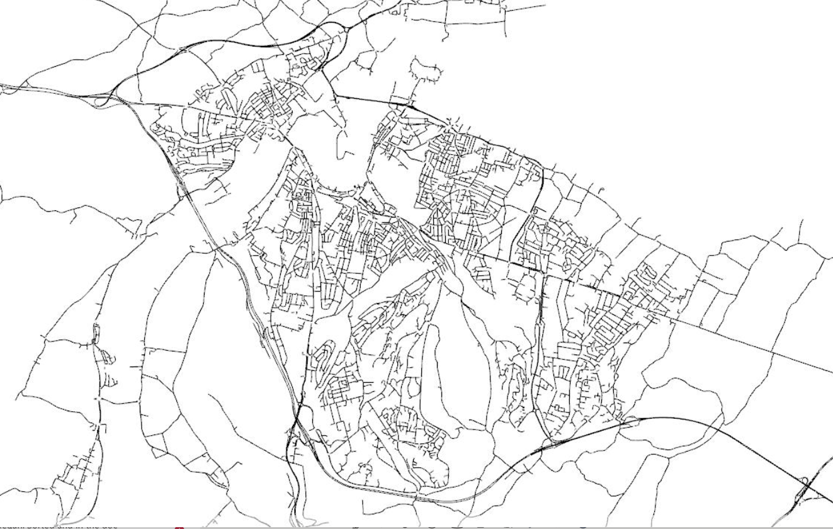
Figure 1 MAM Network in Medway

The base year (2016) MAM was developed by Fore Consulting Ltd (Fore). Any traffic model should be calibrated and validated to base year observed data such as traffic counts, and journey time data. Model calibration refers to adjusting model parameters such as network detail to ensure the model reflects observed traffic conditions and is fit for purpose. Model validation refers to comparing modelled and observed data that is independent to the calibration process. Please refer to the MAM Validation report produced by Fore in the core documents list which details the calibration and validation of the MAM (for data on calibration and validation please see Appendix B of this report). The MAM was calibrated and validated at both macroscopic (i.e. wider area) and microscopic (i.e. localised) levels. This enables the simultaneous modelling of both strategic and localised traffic impacts and mitigations across Medway.

The MAM represents morning and evening peak hours and its 2016 base year demand data is primarily from observed mobile network data. It includes 7 assigned user classes including Car and Light Good Vehicle (LGV) commuting trips, Car, LGV and Heavy Good Vehicle business trips and Car and LGV other trips. It also models the timetabled bus network.

The MAM contains a detailed zoning system primarily at Census Output areas, with some 909 zones in total, each assigned user class trip matrix therefore has demand for some 826,281 origin destination pairs.

A comprehensive dataset of existing and new traffic counts and journey time data has been used in the calibration and validation of the model. Some 2252 link and turn counts were used for model calibration and 317 independent link and turn counts were used for model validation. In addition, 16 observed journey time routes were used, spanning Medway.

The MAM has been calibrated and validated in line with section 3.3 of the Department for Transport’s (DfT) Transport Analysis Guidance (TAG) unit 3.1 (Appendix C) using observed journey times, and traffic counts. The MAM validation is set out in sections 9.3.2 for flow validation and section 9.3.4 for journey time validation in the MAM Validation Report (Appendix B).

To summarise the Medway Aimsun base model calibration and validation results:

Trip matrices have been validated at a screenline level and meet the DfT requirements.

Modelled link and turn flows match well against the observed counts for both macroscopic and microscopic level models, exceeding the DfT’s TAG criteria for both levels of modelling.

Modelled journey times along key routes compare well against observed data for both macroscopic and microscopic level models, exceeding the DfT’s TAG criteria for both levels of modelling.

The model meets the convergence criteria and standards set out in DfT’s TAG

Highways England were satisfied with the base year MAM calibration and validation which they reviewed, as outlined in the email from Nigel Walkden, Highways England to Andrew Bradshaw, Fore, who oversaw the development of the base year MAM (Appendix D).

Model Functioning

The MAM includes both macroscopic (i.e. wider area) and microscopic (localised) modelling. Microscopic modelling is important to capture the detailed local traffic operational effects of schemes and developments, this is achieved through the creation of a pre-defined sub-network. A microscopic model of a sub-network, forecasts individual vehicle acceleration, deceleration and lane changing behaviours. It is needed for accurate assessments of traffic signal operations, detailed junction performance, traffic management and pedestrian interfaces. The MAM runs both macroscopic and microscopic models in conjunction. The macroscopic model is used for understanding strategic reassignment effects, for example how traffic would re-route to a corridor following the introduction of a highway scheme that improves journey times. The Aimsun platform, the transport modelling software, handles all the modelling processes internally including demand, network, traffic signals and public transport information. This allows the network to be modelled at both macroscopic and microscopic levels with interaction and feedback between the different model levels.

The MAM assignment uses generalised cost between each origin destination pair to generate a series of viable paths for vehicles to travel. Generalised cost includes journey times on links (sections of road), turn penalties and junction delays as well as vehicle operating costs which is a function of fuel, non-fuel costs and distance travelled. The assignment is capacity restrained using volume delay, turn penalty delay and junction delay functions from the microscopic modelling. The above assists in forecasting realistic routing in congested future year scenarios.

Table 1 provides a comparison between the MAM and isolated junction modelling which the appellant has used for the Land off Pump Lane development transport assessment using Junction 9/Arcady. As is shown below, an isolated junction model or series of isolated junction models is a very simplistic approach which cannot reflect the complex traffic interactions of a large and congested urban area such as Medway especially when a development of the scale proposed on the land just off Pump Lane is introduced. Unlike use of MAM, an isolated junction model does not capture wider re-routing effects, blocking back effects between junctions, nor does it use observed trip patterns and distributions or provide outputs at a network wide or even corridor level. Even taking traffic flow values from the MAM and running them through isolated junction models would not produce the same traffic impact assessment. Such an approach would not capture detailed traffic operations such as lane changing and interaction between junctions such as blocking back. To just use input flows from the MAM in an isolated junction model would not reflect the reduced capacities at an assessed junction on a congested highway corridor due to upstream traffic queuing through the junction. Such an approach would therefore forecast better traffic operations than would materialise

Table 1 Comparison between MAM and Isolated Junction modelling
Modelling Functionality | Medway Aimsun Model (MAM) | Isolated Junction modelling (conventional transport assessment models)
Spatial extent | Whole of Medway in detail and external network | Isolated junction
Diversionary impact
Traffic routing based on congestion and travel times
Blocking back at junctions (impact of queuing on upstream junctions)
Flow metering (downstream effects of congested junctions)
Individual vehicle lane changing behaviour
Individual vehicle acceleration / deceleration
Bus routes
Corridor journey time analysis
Strategic traffic operation outputs (i.e. V/C)
Strategic Road Network impacts
Distributional analysis (select link analysis)
Observed Traffic Demand Matrices |  | (often assumptions based or uses outdated census data)
Observed Trip Distribution |  | (often assumptions based or uses outdated census data)
Local Journey Purpose Splits |  | (often uses unrepresentative national splits)
Traffic Signal co-ordination and optimisation
Merge/Weave assessment

Medway Aimsun Model Context

The MAM has been developed and used for Medway’s local plan strategic transport assessment to determine the future year traffic impact of local plan developments and to test various mitigations to address this impact such as junction upgrades. It has been scrutinised and approved by Highways England and has been used to assess the traffic impact on the strategic road network including the operations of junctions on the M2 and M20.

The MAM has also been used by developers and their consultants to test developments and associated infrastructure for planning applications. Its use for transport assessments for developments accords with Medway Council’s 2018 guidance note on Transport Assessment on the Medway Council website (see Appendix A).

Since the development of MAM in 2016-17 and the subsequent publishing of Medway Council’s transport assessment guidance in January 2018 which refers to the use of MAM (Appendix A), all new proposed developments of a large scale within Medway have used MAM. This includes the following:
      - East Hill development, an 800-home development in the Capstone Valley, Medway, no decision has been made on this yet, note the size of development is less than the proposed development on the land off Pump Lane
      - Innovation Park, 101,000 square metres of high value technology, advanced manufacturing, engineering and knowledge-intensive businesses around Rochester Airport. This received planning approval. The Masterplan and Local Development Order was adopted by Medway Council’s full cabinet in December 2020. Fore undertook the MAM modelling for the transport impact assessment for the Innovation Park detailed in their modelling report.
      - New secondary school on Otterham Quay Lane, also approved.

Medway Council’s transport assessment guidance (Appendix A) is intended for applicants preparing planning applications for strategic and major developments in Medway, it introduces the MAM and an optional protocol for its use in transport assessments (para 1, section 1, page 1). The advantage of using the MAM is to have a consistent and established baseline and use of a cutting-edge network-wide modelling tool which Medway Council has heavily invested in. By using it, it will enable the Council to understand the wider, cumulative traffic impacts of development and help identify and assess site specific mitigation and design considerations. The guidance states that the MAM enables the council to assess and potentially contest TAs that are based on independent modelling (para 16, section 1, page 4).

The MAM has been well calibrated and validated across the Medway area. It has been used to undertake modelling in several locations including for a bypass scheme in Hoo, Medway tunnel operations, M2 junction improvements and to assess developments in Rochester, Kingsnorth, Capstone Valley and Rainham.

The MAM calibration and validation also included the use of several link and junction counts and journey time data near the proposed development site on the land off Pump Lane. Table 2 below presents a list of roads, junctions and corridors for counts and journey times where model outputs have been successfully calibrated and validated against observed data based on the DfT’s TAG criteria TAG Unit 3.1 (Appendix C). This shows the MAM was not only successfully calibrated across Medway as a whole but also well locally calibrated and validated close to the proposed development. It can therefore be considered robust and fit for purpose as a starting point for its use to assess the traffic impact of the proposed development. This information has been drawn from the MAM Validation Report (Appendix B), the traffic flow calibration is in Appendices D and F of the validation report, while the traffic flow validation is in appendices I and J. Journey time validation can be found in appendices M and N of the validation report.

Table 2 Local link, junction and routes calibrated and validated in the MAM model close to the development
Link Counts | Calibrated / Validated AM Peak time | Calibrated / Validated PM Peak time
Lower Rainham Road Eastbound | ✔ | ✔
Lower Rainham Road Westbound | ✔ | ✔
Lower Rainham Road | ✔ | ✔
Sovereign Boulevard (A2) | ✔ | ✔
London Road (A2) | ✔ | ✔
Ito Way | ✔ | ✔
Hoath Way | ✔ | ✔
Yokosuka Way | ✔ | ✔
Pier Road / Gads Hill | ✔ | ✔
Junctions / Roundabouts
Pier Road Gillingham Gate Road East and West | ✔ | ✔
Yokosuka Way Roundabout | ✔ | ✔
Bowater Roundabout | ✔ | ✔
Ito Way / Sovereign Boulevard (A2) | ✔ | ✔
Yokosuka/Beechings/Ito Way | ✔ | ✔
Bloors Lane / A2 | ✔ | ✔
Otterham Quay Lane / Meresborough Road | ✔ | ✔
Route travel times
Route 7A: A2 Westbound | ✔ | ✔
Route 7B: A2 Eastbound | ✔ | ✔
Route 6A: A289 and A278 Westbound | ✔ | ✔
Route 6B: A289 and A278 Eastbound | ✔ | ✔

MAM Reference Case

Reference Case Planning Data

Sweco and Fore were appointed in late 2017 by Medway Council to undertake the strategic transport assessment of Medway’s local plan. Part of this work required the development of future year Reference Case MAM model scenarios for the following years:

- 2023

- 2028

- 2035 (note, this was later updated to 2037 due to updated data on completions and likely period for the emerging local plan)

The final forecast year represents the end of the plan period for the emerging local plan. The development of the MAM Reference Case scenarios is detailed in the draft Forecasting Report, dated September 2020 (Appendix E).

The Reference Case model builds on the 2016 base year MAM which is based on traffic surveys undertaken in June 2016. The Reference Case scenarios include committed developments. These are residential and non-residential developments which have been granted planning permission, and which the Council consider are likely to be built out by 2028 and 2035/7 as applicable. The relevant information is provided in Appendix F (Committed Residential Developments in Medway), Appendix G (Committed Non-Residential Developments in Medway) and Appendices H&I (2016/17 & 17/18 Updates on completed Residential Developments in Medway) and Appendices J&K (2016/17and 17/18 Update on Completed Non-Residential developments in Medway.

The Reference Case however excludes local plan allocations and all non-committed developments. Local plan allocations were captured as a separate scenario in addition to the committed development as part of Sweco’s work on the local plan.

MAM Reference Case Purpose

The purpose of the Reference Case MAM is to allow one to understand:

      - The effect of a development compared to the Reference Case, as has been undertaken for the proposed development site for the land off Pump Lane (see section 6 of this Proof). For example, the difference between the Reference Case and the “with development” scenario
      - The residual cumulative effect, for example the absolute effect of the “with development” scenario
      - The effect of proposed allocations in the emerging local plan, and the need for mitigation to accommodate these impacts, which is currently being undertaken by Sweco for the strategic modelling for the local plan. This is outside the scope of modelling work for the assessment of the proposed development site for the land off Pump Lane

MAM Reference Case Trip Matrix Development

The development of the 2028 and 2037 Reference Case trip matrices including trip generation and distribution are outlined in chapters 3 and 4 of the forecasting report (Appendix E). Trips associated with committed developments within Medway were estimated using average person trip rates derived from the TRICS Database, a trip generation database based on transport surveys for different development sites across the United Kingdom and Ireland. The person trips are converted to vehicle trips by applying mode share allowing for a range of location dependent factors such as accessibility.

The developments within the Reference Case in Medway have been assigned a model zone and where necessary, new zones have been created. The vehicle arrivals and departures are then summed for each zone and added to the respective destination and origin totals to provide the growth in traffic for each zone within the Medway local authority area. In this way, growth for trip ends within Medway are based solely of the projected development in the Reference Case Scenarios.

For all other zones in the model (i.e. those outside of Medway) trip end growth for non-home-based work, LGV and HGV trips has been based on the forecasts contained in “Road Traffic Forecasts 2015” for LGV, rigid and articulated vehicle types.

5.10 Trip end growth for all car trips and other LGV trips outside of Medway (e.g. in neighbouring authorities) has been estimated using the DfT’s National Trip End Model (NTEM) using the software TEMPro version 7.2. The resulting growth factors have also been modified using the income and fuel adjustment factors set out in TAG Databook Table M4.2.1.

A furnessing procedure has been used to distribute the future origin and destination totals for the Reference Case in order to update the trip matrices. This uses the base year trip distribution.

The resultant traffic growth in the trip matrices between the base year and Reference Case Matrices has been checked through a comparison with the National Transport Model (NTM) for Goods Vehicles growth and NTEM (TEMPro) for car traffic growth for Medway, as can be seen in Table 3 the NTM/NTEM growth is higher (See Table 14, section 4.5 of Appendix E). This is expected considering the Reference Case excludes any traffic associated with Adopted Local Plan allocations whereas NTEM will make some allowance for this.

Table 3 MAM Traffic Growth versus NTEM Traffic Growth for Medway
Year | MAM Traffic Growth |  | NTM/NTEM Traffic Growth for Medway
 | AM Peak | PM Peak | AM Peak | PM Peak
2028 | 113.4% | 112.0% | 116.4% | 116.4%
2037 | 119.4% | 118.3% | 123.7% | 123.4%

Reference Case Highway Networks

The Reference case highway networks have been developed by coding in committed highway schemes including schemes associated with committed developments. These are detailed in Chapter 5 of the Forecasting Report (Appendix E).

The 2023, 2028 and 2035/37 Reference Case scenarios have been run by assigning the future trip matrices (demand) to both the macroscopic and microscopic models. The microscopic modelling has been run 10 times with average results taken to account for traffic variability.

2037 Reference Case

In early 2020 the final forecast year Reference Case was updated from 2035 to 2037 given the likely end date of Medway’s emerging local plan. It is also included completed developments between 2018 and 2019.

Highways England Approval

The development of the Reference Case scenarios and the forecasting methodology has been agreed with Highways England as part of the work Sweco is undertaking on Medway Council’s local plan strategic transport assessment. The work has required close and ongoing liaison between Sweco, Medway Council and Highways England.

MAM Assessments for the Land Off Pump Lane Development

Several assessments using the MAM have been undertaken to look at the Land off Pump Lane development in the Lower Rainham Area:
- December 2019 assessment using a 2035 forecast year (Appendix L)
- October 2020 assessment using a 2037 forecast year (Appendix M)
- December 2020 assessment using a 2037 forecast year and (amongst other scenarios) the appellant’s assumptions (Appendix N)
- January 2021 assessment using a 2028 forecast year and (amongst other scenarios) appellant’s assumptions (Appendix O)

December 2019 assessment using a 2035 forecast year

Firstly, an assessment was undertaken by Sweco in December 2019 looking at 1250 homes on the Land off Pump Lane development. The development was added to a previous 2035 forecast year Reference Case scenario. PowerPoint slides provided to the appellant by Medway Council summarised the modelling results from the MAM. These PowerPoint slides are provided in Appendix L. The modelling work included both macroscopic modelling and three sub-networks where more detailed microscopic model data could be extracted including for Lower Rainham Road, the A2 and Pier Road/Yokosuka Way. The sub-networks known as Subnetwork 2, Subnetwork 3, Subnetwork 7 used for the microscopic modelling, including detailed output of corridor journey time and junction performance are shown in Figure 2. These sub-networks were chosen as they had been previously used in the local plan work. They were also the sub-network closest to the proposed development and considered to be the corridors most likely impacted by the additional proposed development traffic

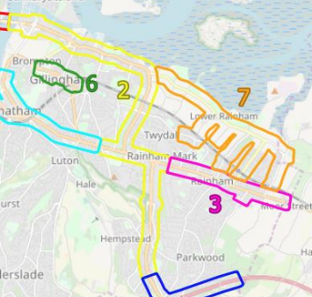
Development zone
Figure 2 MAM Subnetworks

October 2020 assessment using a 2037 forecast year

Secondly, in October 2020, the previous December 2019 assessment was updated. This therefore supersedes the December 2019 assessment. The same development assumptions and access points were assumed. The update to the modelling related to the use of a 2037 forecast year reference case model which aligned with the full local plan build out. This reflected the latest changes in committed developments within Medway based on updated information available to Medway Council. It also included updated information regarding future development in neighbouring Swale Borough. Additional future highway schemes were also included however these were some distance from the Land off Pump Lane, such as planned improvements at M2 junction 5 and M20 junction 7 and would therefore have no material impact on the assessment. The updated MAM modelling work and results are outlined in the Pump Lane and Lower Rainham Transport Impact Appraisal Report provided in Appendix M. At the request of the appellant, a significant amount of additional analysis and model outputs were also provided as part of this work, including:

select link analysis at the entry and exit points to and from the assessed development

flow difference bandwidth plots with and without the development

volume over capacity network stress diagrams
      - link speed outputs
      - junction delay bandwidths
      - flow plots

- December 2020 assessment using a 2037 forecast year and appellant’s assumptions

6.4 Thirdly, in December 2020, following further correspondence between the appellant and Medway Council, additional modelling using the MAM was undertaken and reported as an addendum to the October 2020 modelling work and therefore did not supersede it. The December 2020 modelling sought to address issues raised by the appellant, which included:

- A model run using the appellants trip generation assumptions for the proposed development which were some 26-31% lower than what had been assumed in the previous MAM modelling work.
- Representation of the proposed development in its own MAM zone
- Changes to the centroid connectors (zone loading points to the network) to more accurately reflect the latest access points to the proposed development.

Again the 2037 Reference Case model was used as a starting point. The modelling work and results were outlined in the Lower Rainham Report Addendum (2037 results) provided in Appendix N.

- January 2021 assessment using a 2028 forecast year and appellant’s assumptions

Finally, in January 2021, as a further addendum to the October 2020 modelling, the equivalent MAM runs for a 2028 forecast year were produced with the modelling work and results detailed in the Lower Rainham Report Addendum 2 (2028 results) provided in Appendix O. From the local plan work we had a 2028 scenario available, given the proposed development opening year was 2029 then the use of 2028 was a best- case scenario where the development could be bought forward. More likely it would be later than 2029 hence the 2037 assessments. For the 2028 assessment the same level of trip generation for the proposed development site on the land just off Pump Lane was used as was assumed for the 2037 assessment undertaken in December 2020 including the use of the appellants trip rates. The only difference between 2028 and 2037 assessments was therefore the background traffic growth from the 2016 base year and the level of committed development build out between 2016-2028 and 2016-2037 for the Reference Case scenarios which “the with development” scenario was layered upon.

Conclusions of MAM Assessments for the Land Off Pump Lane Development

Levels of Service Criteria

The MAM produces outputs relating to traffic operational performance for junctions and corridor speeds, for each it uses a Level of Service (LoS) performance metric. For junctions, the Level of Service (LoS) is a measure based on the average delay experienced by vehicles. Different delay values are assigned an alphabetical grade, from A to F. It is commonly used around the world. In respect of junction delay, the thresholds for the various levels of service are shown in Table 4 and are drawn from the Highway Capacity Manual (HCM) version 6 (2016). For corridor speeds the LOS classification uses the average speed of the links as a percentage of the free flow speed using defined journey time routes from the sub-network. Thresholds for the levels of service for corridor speeds are provided in Table 5.

Table 4 Level of Service Thresholds for junction delay
Level of Service | Delay (sec/veh) |  | Definition
 | Signalised | Unsignalised
A | ≤10 | ≤10 | Free flow conditions
B | 10-20 | 10-15 | Reasonably free flow conditions
C | 20-35 | 15-25 | Stable flow conditions
D | 35-55 | 25-35 | Approaching unstable flow, ability to manoeuvre restricted due to congestion
E | 55-80 | 35-50 | Unstable flow, at or near capacity
F | > 80 | > 50 | Forced or breakdown flow, demand > capacity

Table 5 Level of Service Thresholds for Link Speeds
Level of Service | Speed (% of free flow speed) | Definition
A | >85 | Free flow conditions
B | >67 & <=85 | Reasonably free flow conditions
C | >50 & <=67 | Stable flow conditions
D | >40 & <=50 | Approaching unstable flow, ability to manoeuvre restricted due to congestion
E | >30 & <=40 | Unstable flow, at or near capacity
F | <=30 | Forced or breakdown flow, demand > capacity

December 2019 Modelling Assessment

For the December 2019 work which the officers report was based upon the following summarises the results that were found when comparing the 2035 Reference Case and “with development” scenarios, further detail can be found in the assessment in Appendix L:

Subnetwork 2 (see page 15, Appendix L)

Due to the additional development flows the junctions of London Road / Bloors Lane as well as the Bowater roundabout both went from LoS D to LoS F with the development.

The following corridor speeds deteriorated with the development, Lower Rainham Road to Medway tunnel went from LoS D to LoS, Medway Tunnel to Gillingham Gate Road went from LoS C to LoS F, Medway tunnel to Hoath Way went from LoS C to LoS F.

Subnetwork 3 (see page 33, Appendix L)

Due to the additional development flows the junction of Sovereign Boulevard / Station Road went from LoS D to LoS F with the development.

The following corridor speeds deteriorated with the development, Meresborough Road to Otterham Quay Lane and Moor St to Sovereign Boulevard went from LoS E to LoS F.

Subnetwork 7 (see page 51, Appendix L)

Due to the additional development flows the junction of Lower Rainham Road and Berengrave Lane went from LoS C to LoS E and Lower Rainham Road westbound corridor speeds significantly deteriorate from LoS B to LoS F.

The above is largely due to additional development flow especially on the A289, A2 and Lower Rainham Road impacting on traffic operations.

It can be seen from the above that the development has a significant traffic operational impact both locally and across a wider area.

October 2020 Modelling Assessment

For the October 2020 modelling work similar impacts were noted (see Appendix M section 11 at page 75). Even with the lowest level of assumed housing (sensitivity test 1) which represents the appeal proposal, a significant impact on travel times is forecast by the MAM compared to the Reference Case. The proposed development resulted in a 43% increase in average network delay in subnetwork 2, a 7% increase in subnetwork 3 and a significant 76% increase in subnetwork 7 in the worst peak period. In addition, the LoS in most of the key junctions in all subnetworks deteriorates significantly reaching LoS F indicating that flow at the junction exceeds capacity, with the following junctions, similar to the December 2019 work, being most heavily impacted:

London Road / Bloors Lane junction

Bowater Roundabout

Pier Road / Maritime Way Roundabout

Yokosuka Way Roundabout

Otterham Quay Lane / Meresborough Junction

B2004 Lower Rainham Road / Berengrave Lane junction

This can only be summarised once again as a significant traffic impact that the proposed development would have both on the local network in Rainham and the wider network too.

December 2020 Modelling Assessment

For the December 2020 work (2037 results) the MAM modelling showed there is no improvement in congestion through using the appellant’s trip rates, a separate development only zone or changes to the centroid connectors compared to the October 2020 modelling (see Appendix M page 25, section 4). We would refer you to LLR scenario 3 which represents the appellant’s best case through use of the developer’s trip rates and a standalone development zone and loading points (centroid connectors). Indeed, a further development impact issue was identified at the junction of the A2 with Otterham Quay Lane and Meresborough Road in subnetwork 3 due to the changes to the centroid connectors requested by the appellant. The junctions demonstrated to be problematic in the October 2020 modelling with the proposed development remained an issue.

More specifically, the results showed the following junctions reaching a LoS F in the morning peak resulting in significant queuing and delays as a result of the development.

- A2 (Rotary Gardens / Woodlands Road / Sovereign Boulevard Junction)
- A2 (Bowater Roundabout)
- A289 (Ito Way / Sovereign Boulevard)
- A2 (Otterham Quay Lane / Merersborough Road)

And evening peak:

- A289 (Pier Road / Maritime Way Roundabout)
- A289 Pier Road / Gillingham Gate Road West
- A2 (Bowater Roundabout)
- Eastcourt Lane / South Avenue
- A2 (Otterham Quay Lane / Merersborough Road)

The following journey time routes showed a significant increase in travel times with the proposed development.

- Lower Rainham Road westbound shows a large increase in travel time (approximately 10 minutes) in the morning peak.
- A2 (Moor Street to Sovereign Boulevard) in subnetwork 3 shows an increase of 5 minutes in the evening peak.
- The A289 (Church Street) to A278 (Hoath Way) show substantial increases in travel time in both peaks and the A2 (Watling to Sovereign Boulevard) in the morning peak show a substantial increase in travel time in subnetwork 2

January 2021 Modelling Assessment

Finally, when comparing the 2037 with the 2028 (January 2021 modelling) results, no significant difference in terms of congestion hotspots was observed (see Appendix O, page 26 section 4). The problems in the road network underlined in the Pump Lane and Lower Rainham Transport Impact Appraisal Addendum (2037 results) remain, despite the reduction in traffic growth due to using the 2028 rather than 2037 forecast year. Note the development traffic remained the same.

It is worth mentioning that one of the congestion hotspots identified in the December 2020 and January 2021 reports was caused by the blocking back effects that can be only identified using MAM. In fact, Figure 4 demonstrates the blocking back effect occurring in MAM in the AM Peak LRR Scenario 6. The development traffic coming down on the A2/Bloors Lane Junction is causing additional congestion which shifts the level of service of this junction from A to E. This disruption causes a chain effect on the A2, ultimately reaching Ito Way/Sovereign Boulevard roundabout, leading to the formulation of long queues along Ito Way southbound. This shifts the level of service of Ito Way/ Sovereign Boulevard roundabout to F. This phenomenon is not observed in the 2028 reference case scenario where the development is not present, as shown in Figure 3.

Figure 3 Reference Case 2028 traffic conditions along the A2 at 8.30am
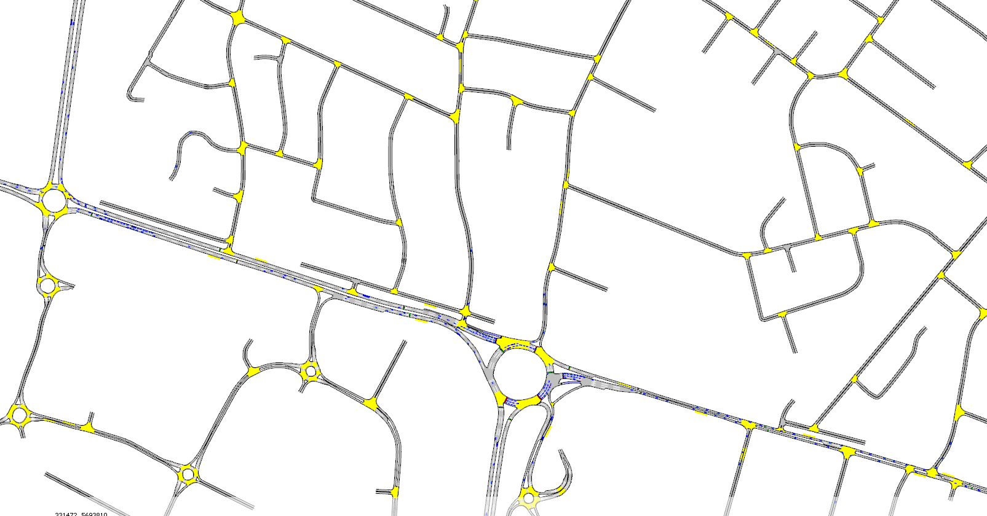

Figure 4 2028 LRR Scenario 6 traffic conditions along the A2 at 8.30am
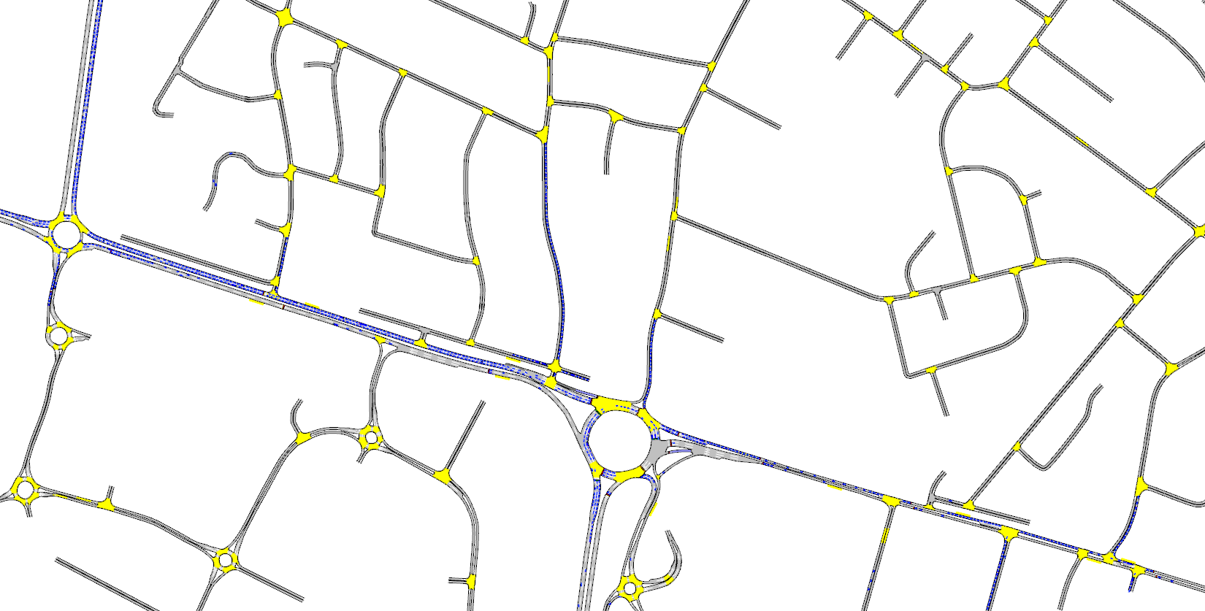
Development traffic

Responses to Appellants criticisms of the MAM modelling work

Several queries have been raised by the appellant about the MAM modelling work undertaken to assess the proposed development for the Land off Pump Lane. Most of them can be found in a letter from the appellant to Medway Council on the 8th of December 2020 (see Appendix P). These queries could be summarised as:

- Trip generation assumptions

- Access arrangements to the proposed development

- Proposed Mitigation

- Development only zone

- Growth assumptions with respect to cumulative and committed development and the use of TEMPro

- Trip generation and distribution queries

Trip Generation Assumptions

This includes that the “MAM modelling has 50% more traffic from the development than there should be”. We disagree with this assertion, which relates to trip generation. The approach in the MAM modelling for the proposed development is consistent with the trip generation process and trip rates from TRICs that has been used to assess the future year MAM reference case and local plan development sites. However, in any event, as part of the December 2020 additional MAM modelling, Sweco ran a scenario using the appellants trip generation assumptions for the proposed development and the conclusions regarding traffic impact remain unchanged. Therefore, whether the appellants trip rates or the original trip rates used in MAM are used, it has been proven to have no bearing on the forecast traffic impact. Even with the appellant’s trip generation assumptions the traffic impact of the proposed development remains significant.

- Access arrangements to the proposed development
- Access arrangements to the proposed development

Access arrangements to the proposed development

The appellant also queried how the access arrangement to the proposed development had been modelled in the MAM citing a centroid connector from the zone which contained the development to Lower Bloors Lane which does not reflect the proposal. The December 2020 and January 2021 additional MAM modelling (Appendix M and Appendix N) updated the centroid connectors to reflect the latest proposed development access arrangement. Again, this had no bearing on the conclusions of the previous MAM modelling work, in fact it extended the traffic impact, as it worsened the junction performance of the A2 junction with Otterham Quay Lane and Meresborough Road, which was previously less affected. Again, even with slight adjustments to the centroid connector loadings, the traffic impact of the proposed development remains significant.

Proposed Mitigation

The appellant also queried whether the MAM modelling included the mitigation proposed by the appellants. It can be confirmed that the proposed development mitigation at the Yokosuka Way/Lower Rainham Road roundabout, A2/Bloors Lane and the Pump Lane Railway bridge improvements with signalisation were all included in the MAM modelling work.

Development only Zone

The appellant also queried why the proposed development was modelled using an existing MAM zone which already contained underlying zonal demand in the vicinity of Pump Lane. In the December 2020 additional MAM modelling work, Sweco ran several scenarios where the development was modelled with its own dedicated MAM zone. Once again, this change had no impact on the conclusions of the previous MAM modelling work and the traffic impact of the proposed development remained significant.

Growth Assumptions

The appellant queried the growth assumptions included in the MAM modelling. Sweco responded to this query in the letter presented in Appendix Q. We outlined that for future year traffic growth, additional trips to or from Medway zones are based on committed developments and their associated trip generation. External car traffic growth of surrounding authorities has been constrained to DfT National Trip End Model (i.e. TEMPro). Sweco has provided detailed traffic growth factors and the corresponding person and vehicle trip factors for Medway developments. Additionally, with regards to Planning Policy Guidance on Transport Assessment that the appellant referenced, Sweco indicated that the resultant car traffic growth from TEMPro for Medway between 2016 and 2037 is in fact higher than the car traffic growth in the MAM. The TEMPro growth versus the growth in the MAM can be found in Appendix R. Therefore, if TEMPro traffic growth was applied to the MAM the traffic impact from the proposed development would be even more severe.

Trip Generation and Distribution queries

The appellant finally queried the vehicle trip generation and distribution. Sweco has appended an spreadsheets containing the development site reference and the corresponding TRICS database lookup tables in Appendix M. Regarding trip distribution, Sweco has provided the trip matrices which show the demand to and from the development zone to and from all other MAM zones. The methodology that has been used for this distribution is outlined in Appendix M. The future year development trip distribution and consequently the MAM demand matrices are largely based on observed mobile phone origin-destination data. The matrices have been subsequently adjusted to fully match observed data with no trip synthesis. The proposed development distribution is therefore based on the existing observed trip distribution for the area. The full trip generation and distribution methodology can be found in the Medway Aimsun Model Validation Report document (Appendix B Section 6).

Summary

The MAM has been used to undertake several assessments of the proposed development on the Land off Pump Lane. This has included MAM modelling work undertaken by Sweco and reported in December 2019, October 2020, December 2020 and January 2021.

The MAM assessments have reflected the size, scale, location and associated mitigations of the proposed development.

Later MAM assessments (December 2020 / January 2021 modelling) have varied the input assumptions to the modelling. Following feedback from the appellant, changes were made to the trip generation assumptions, use of different forecast years, updated development access points and giving the development its own MAM zone. None of these changes have altered the original conclusions that the development is forecast to have a significant traffic impact.

The MAM is the most appropriate tool to undertake this assessment given the congested nature of Medway’s network with many junctions at or close to capacity, There is therefore a need to model the inter-relationships between junctions such as blocking back and wider re-routing effects that only the MAM provides, and this is outlined in Medway Councils transport assessment guidance available on Medway’s website.

The MAM assessment has consistently shown a traffic impact of the proposed development on several junctions and key routes within Medway. This includes the following junctions and roundabouts failing (LoS F) in either or both the AM and PM peak periods: Rotary Gardens/Woodlands Road/Sovereign Boulevard junction, Bowater Roundabout, Ito Way/Sovereign Boulevard Roundabout, Otterham Quay Lane/Meresborough Road Junction, Pier Road/Maritime Way Roundabout, Eastcourt Lane/South Avenue Junction and Pier Road/Gillingham Gate Road West. The routes that are most significantly affected by the proposed development in terms of deteriorating travel times are: Lower Rainham Road westbound, A2 Moor Street to Sovereign Boulevard, A289 (Church Street) to A278 (Hoath Way) and A2 Watling Street to Sovereign Boulevard.

The MAM base model which covers the whole of Medway and beyond has been well calibrated and validated against an extensive observed dataset unlike the isolated junction models. It has also been signed off by Highways England. The distribution of existing, future and development trips are based on observed local data rather than based on assumptions from elsewhere. The outputs provide network-wide statistics, corridor operational metrics and a clear overview of the traffic impact providing a consistent basis with other developments assessed using MAM including the local plan work. The MAM is the best and robust tool for this assessment.

